**SIMULATION OF REAL STOCK MARKET!**

[](http://www.google.com.au/url?sa=i&rct=j&q=&esrc=s&source=images&cd=&cad=rja&uact=8&ved=0ahUKEwjn94ODvZTKAhVI4qYKHaWjAYAQjRwIBw&url=http://www.dreamstime.com/royalty-free-stock-photos-buy-hold-sell-conceptual-colorful-road-signs-stock-market-options-actions-image32902398&bvm=bv.110151844,d.dGY&psig=AFQjCNHy1Yfa-H9V0LjRE-XuV0H2Ioe0sQ&ust=1452142510385448)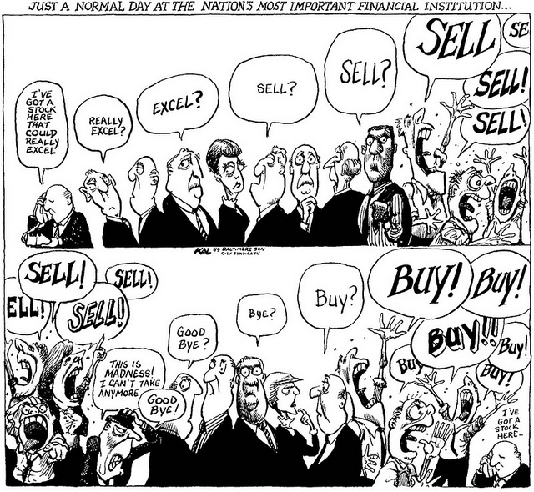





Sign in now to participate in the simulation!

Pre-registration will be at:

(googleformat)



We are going to run a game, simulating a real stock market. We will provide Type text or a website address or [translate a document.](https://translate.google.com.au/?tr=f&hl=en)

fictional money and shares during the simulation and you, will take part in each round to increase your wealth by carrying out your action

DURATION: 2 HOURS

LOCATION: PNR Learning Studios

DATE: (exact date will be decided on March)

For further information please contact:

Karina Arias C.

Email: [Karina.arias.c@gmail.com](mailto:Karina.arias.c@gmail.com)

Facebook: Karina Arias Calluari

JOIN TO US AND LEARN HOW TO INVEST IN A REAL STOCK MARKET!!!!!!